Two Bedroom Cabin
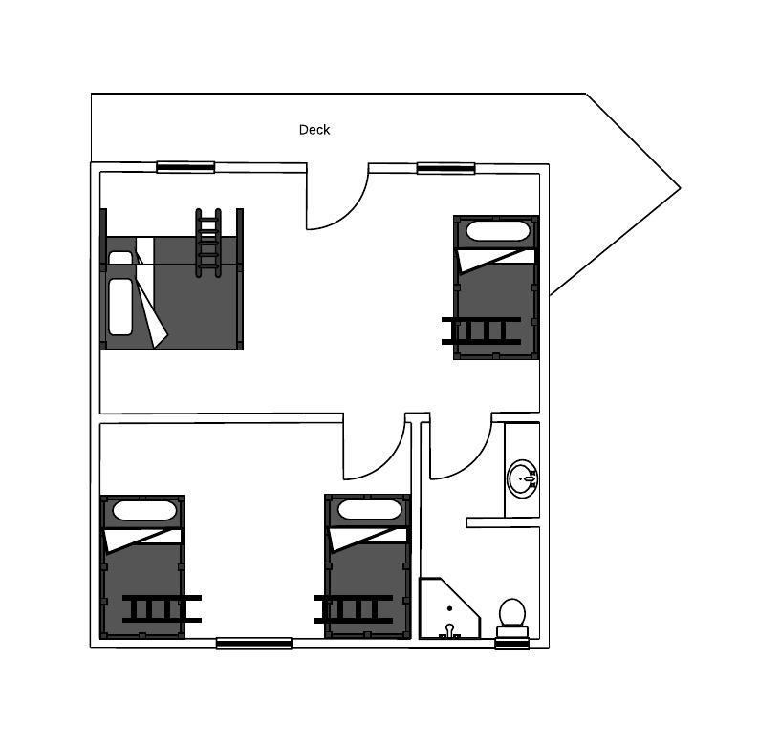

Number of People | Two Bedroom Cabin | Per Person  Costs
1 | $300 per night | $300 per person
2 | $300 | $150
3 | $300 | $100
4 | $300 | $75
5 | $330 | $66
6 | $360 | $60
7 | $390 | $55.71
8 | $420 | $52.50
9 | $450 | $50

The Hut

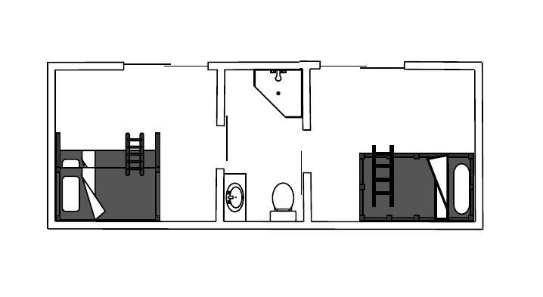

Number of People | Two Bedroom Hut | Per Person  Costs
1 | $300 | $300 per person
2 | $300 | $159
3 | $300 | $100
4 | $300 | $75
5 | $330 | $66

PRICING GUIDE

Depending on whether budget or privacy is required, listed below is the minimum and maximum cost for guest numbers up to 59. If you would like to go for a customised option and require a quotation, please download the guest configuration pdf, fill in and return the form via email.

Guest Numbers | Lowest Price  (accommodate max guests in minimum cabins) | Cabins allocated for this price | Maximum Price  (spread your group across max cabins) | Cabins allocated for maximum cabins
1 | $200 | 1 | $200 | 1
2 | $230 | 1 | $600 | 2
3 | $230 | 1 | $900 | 3
4 | $260 | 1 | $1200 | 4
5 | $290 | 1 | $1500 | 5
6 | $360 | 1 | $1800 | 6
7 | $390 | 1 | $2100 | 7
8 | $420 | 1 | $2100 | 7
9 | $450 | 1 | $2100 | 7
10 | $580 | 2 | $2100 | 7
11 | $650 | 2 | $2100 | 7
12 | $680 | 2 | $2100 | 7
13 | $710 | 2 | $2100 | 7
14 | $740 | 2 | $2100 | 7
15 | $810 | 2 | $2100 | 7
16 | $840 | 2 | $2100 | 7
17 | $870 | 2 | $2100 | 7
18 | $900 | 2 | $2100 | 7
19 | $1030 | 3 | $2100 | 7
20 | $1100 | 3 | $2100 | 7
21 | $1130 | 3 | $2100 | 7
22 | $1160 | 3 | $2100 | 7
23 | $1190 | 3 | $2100 | 7
24 | $1260 | 3 | $2100 | 7
25 | $1290 | 3 | $2100 | 7
26 | $1320 | 3 | $2100 | 7
27 | $1350 | 3 | $2100 | 7
28 | $1480 | 4 | $2100 | 7
29 | $1530 | 4 | $2130 | 7
30 | $1580 | 4 | $2160 | 7
31 | $1610 | 4 | $2190 | 7
32 | $1640 | 4 | $2220 | 7
33 | $1710 | 4 | $2250 | 7
34 | $1740 | 4 | $2280 | 7
35 | $1770 | 4 | $2310 | 7
36 | $1800 | 4 | $2340 | 7
37 | $1930 | 5 | $2370 | 7
38 | $2000 | 5 | $2400 | 7
39 | $2070 | 5 | $2430 | 7
40 | $2100 | 5 | $2460 | 7
41 | $2130 | 5 | $2490 | 7
42 | $2160 | 5 | $2520 | 7
43 | $2190 | 5 | $2550 | 7
44 | $2230 | 5 | $2590 | 7
45 | $2250 | 5 | $2610 | 7
46 | $2380 | 6 | $2640 | 7
47 | $2450 | 6 | $2670 | 7
48 | $2520 | 6 | $2700 | 7
49 | $2550 | 6 | $2730 | 7
50 | $2580 | 6 | $2760 | 7
51 | $2610 | 6 | $2790 | 7
52 | $2640 | 6 | $2820 | 7
53 | $2670 | 6 | $2850 | 7
54 | $2700 | 6 | $2880 | 7
55 | $2840 | 7 | $2910 | 7
56 | $2940 | 7 | $2940 | 7
57 | $2970 | 7 | $2970 | 7
58 | $3000 | 7 | $3000 | 7
59 | $3030 | 7 | $3030 | 7

